Sprint 3 – Agility Design Document

December 4, 2023

Table of Contents

1. Executive Summary 3

1.1 Project Overview 3

1.2 Purpose and Scope of this Specification 3

2. Product/Service Description 3

2.1 Product Context 3

2.2 User Characteristics 3

2.3 Assumptions 3

2.4 Constraints 3

2.5 Dependencies 3

3. Requirements 4

3.1 Functional Requirements 4

3.2 Security 4

3.2.1 Protection 4

3.2.2 Authorization and Authentication 4

3.3 Portability 4

4. Requirements Confirmation/Stakeholder sign-off 4

5. System Design 5

5.1 Algorithm 5

5.2 System Flow 5

5.3 Software 6

5.4 Hardware 6

5.5 Test Plan 7

5.6 Task List/Gantt Chart 7

5.7 Staffing Plan 8

# Executive Summary

## Project Overview

The current project is to test the agility of a Sphero Bolt Robot when travelling through an obstacle course. Using specific software for the robot and block code, the goal is to program the robot to successfully and accurately move around the obstacle course, avoid all objects, successfully roll up a ramp, and knock down as many pins as possible.

## Purpose and Scope of this Specification

The purpose of this specification is to have University Students program a robot to perform several different sprints accurately and efficiently.

In Scope

This document addresses requirements related to Sprint 3 of The Robot Project:

* Program the robot to successfully run an obstacle course in room HH 208, avoiding 3 objects, going up a ramp, and knocking over pins.

Out of Scope

The following items of The Robot Project are out of scope:

* Sprint 1: Program the robot to circumnavigate a rectangular track.
* Sprint 2: Program the robot to accurately run a figure 8 course 5 times.

# Product/Service Description

## Product Context

This Sphero Bolt Robot is part of an entire line of other robots, such as the Sphero Sprk and Sphero Sprk+. The Sphero Bolt Robot used for this project can be controlled through block code via the Sphero Edu software. The robot has the ability to roll to specific locations at certain speeds and directions, as well as turn specific colors and speak.

## User Characteristics

* University Student
* First Year CS/SE Major
* Entry Level Programming Knowledge

## Assumptions

* Assumes the Sphero Edu software is already installed on device.
* Assumes that robot is calibrated to face the initial direction it will move in before starting program.

## Constraints

* Size of the classroom HH 208.
* Limited availability of HH 208.

## Dependencies

* Requires up to date version of Sphero EDU software.

# Requirements

## Functional Requirements

| Req# | Requirement | Comments | Priority | Date Rvwd | SME Reviewed / Approved |
| --- | --- | --- | --- | --- | --- |
| AGIL_01 | Travel the obstacle course. | Robot must navigate the obstacle course efficiently. | Priority 1 | 11/28/23 | Chris, Marwan, Mike |
| AGIL_02 | Begin in the starting square. | The course must begin at the starting square which the robot will start from. | Priority 1 | 11/28/23 | Chris, Marwan, Mike |
| AGIL_03 | Avoid collisions. | Robot must be able to navigate around 3 objects without collision. | Priority 1 | 11/28/23 | Chris, Marwan, Mike |
| AGIL_04 | Navigate over the ramp. | Robot must successfully travel over the stationed ramp. | Priority 1 | 11/28/23 | Chris, Marwan, Mike |
| AGIL_05 | Strike down the pins. | Robot must end the course knocking down as many pins as possible. | Priority 1 | 11/28/23 | Chris, Marwan, Mike |

## Security

### Protection

* The main factor that protects the system from accidental access is Bluetooth connection to a specific device. A Bluetooth connection must be made to the robot to connect to it, and only one user can connect at a time.

### Authorization and Authentication

* To authorize robot use, the user must know robot name to authenticate it through the Sphero Edu Software.

## Portability

* High environmental independence
* Compatible with iOS, Android, Windows, and MacOS.

# Requirements Confirmation/Stakeholder sign-off

|  |  |  |
| --- | --- | --- |
| Meeting Date | Attendees (name and role) | Comments |
| 11/28/23 | Chris D., Marwan E., Mike M. | Confirmed all requirements. |

# System Design

## Algorithm

* Start
* Step 1: Roll 0 degrees at 48 speed for 2.5 seconds.
* Step 2: Stop
* Step 3: Delay for 1 second.
* Step 4: Roll 92 degrees at 44 speed for 3.6 seconds.
* Step 5: Stop
* Step 6: Delay for 1 second.
* Step 7: Roll 2 degrees at 44 speed for 4 seconds.
* Step 8: Stop
* Step 9: Delay for 1 second.
* Step 10: Roll 95 degrees at 190 speed for 2.3 seconds.
* Step 11: Stop
* Step 12: Delay for 1 second.
* Step 13: Roll 230 degrees at 200 speed for 4 seconds.
* Step 14: Stop
* Done.

## System Flow

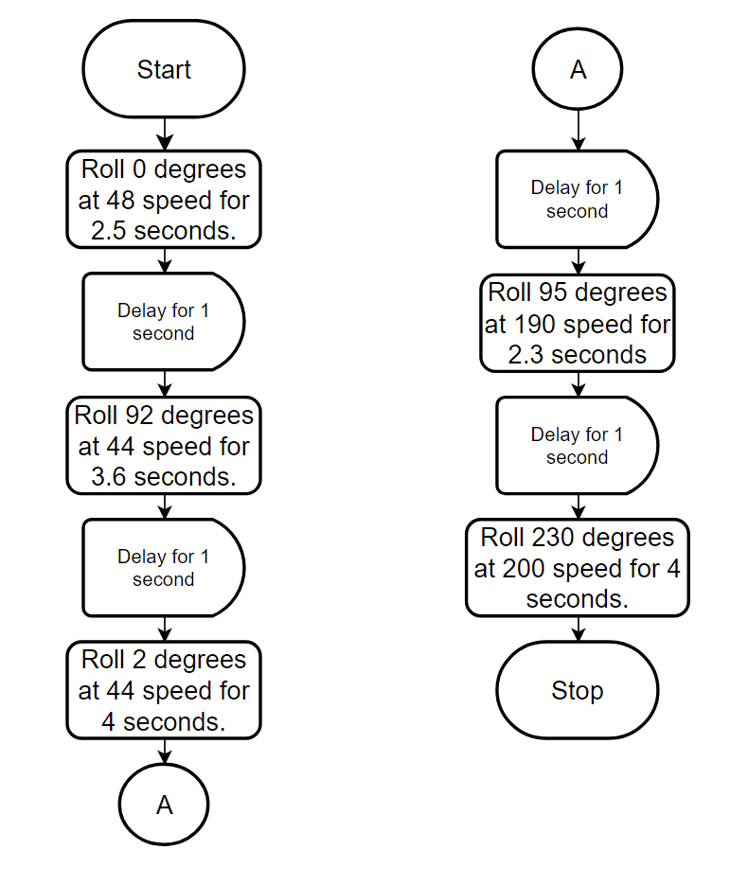

## Software

The software used for this project was block code in the Sphero Edu application.

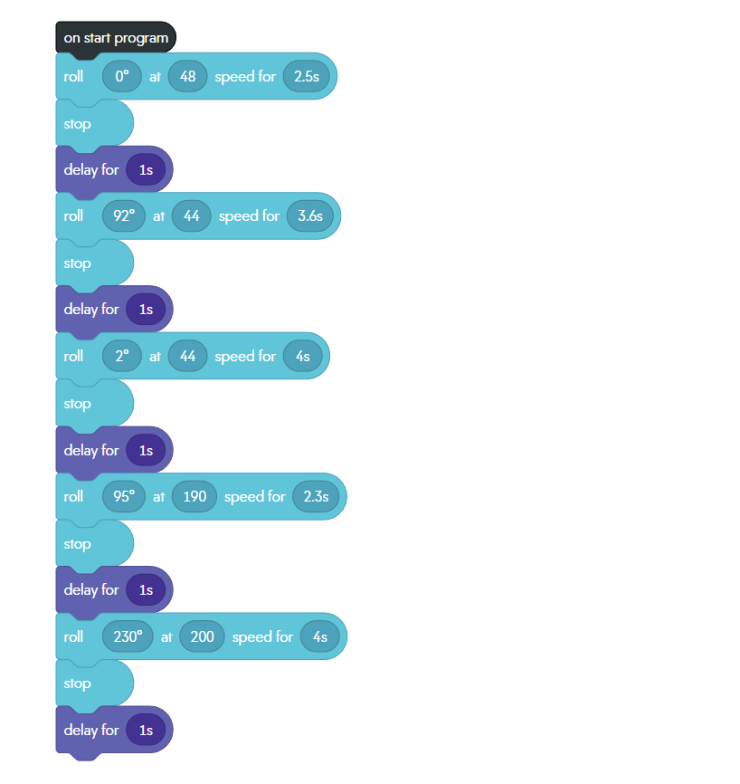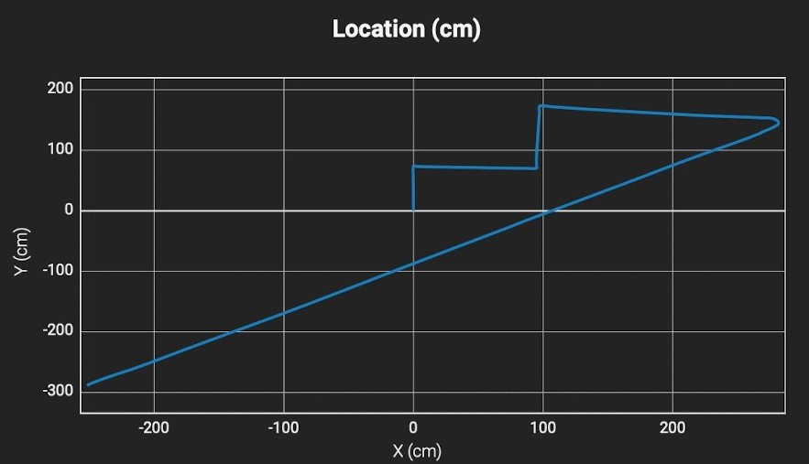

## Hardware

Hardware platforms used:

* Apple MacBook Air
* Apple iPhone
* Sphero Bolt.

## Test Plan

| **Reason for Test Case** | **Test Date** | **Expected Output** | **Observed Output** | **Staff Name** | **Pass/Fail** |
| --- | --- | --- | --- | --- | --- |
| Test if Robot avoids the first object. | 11/28/23 | Robot will go around the object without hitting it. | Robot collided with the object. | Chris, Marwan, Mike | Fail |
| Test if Robot avoids the first object. | 11/28/23 | Robot | Robot successfully completed the full circle. | Chris, Marwan, Mike | Pass |
| Test if Robot avoids the second object. | 11/28/23 | Robot goes around both circles accurately in a figure 8. | Robot went around the first circle accurately, then did not complete the other circle. | Chris, Marwan, Mike | Pass |
| Test if Robot avoids the third object. | 11/28/23 | Robot goes around both circles accurately in a figure 8. | Robot successfully went around both circles accurately in a figure 8. | Chris, Marwan, Mike | Pass |
| Test if Robot successfully goes over the ramp. | 11/28/23 | Robot will roll over the ramp. | Robot did not roll up the ramp fully and fell off it. | Chris, Marwan, Mike | Fail |
| Test if Robot successfully goes over the ramp. | 11/28/23 | Robot will roll over the ramp. | Robot successfully rolled up and over the ramp. | Chris, Marwan, Mike | Pass |
| Test if Robot knocks over the pins. | 11/28/23 | Robot will knock over the pins at the end of the course. | Robot successfully knocked over the pins. | Chris, Marwan, Mike | Pass |

## Task List/Gantt Chart

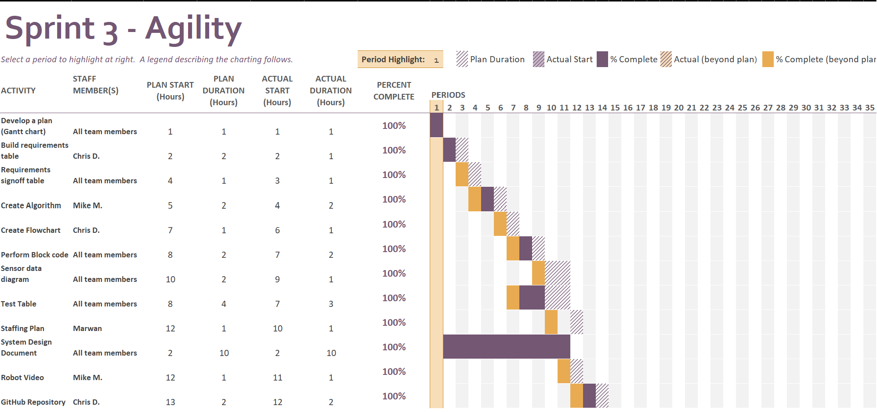

## Staffing Plan

| Name | Role | Responsibility | Reports To |
| --- | --- | --- | --- |
| Chris DeTullio | Group Member | GitHub Repository Owner, Flowchart, Requirements Table | Mike and Marwan |
| Marwan Elgoghel | Group Member | Staffing Plan, Test Table | Chris and Mike |
| Mike Montulet | Group Member | Algorithm, Robot Video | Chris and Marwan |